NNITS Network Infrastructure

Project Documentation
Name: Mario Dumba

1. Company Overview
Company Name: NNITS (Namibia National Institute of Technology Services)
Industry: Information Technology and Administration
Headquarters: Kavango East, Namibia
Branches: Kavango West, Zambezi, Ohangwena, Oshana, Omusati, Kunene, Oshikoto, Khomas
About the Company:
NNITS is a fictional organization designed to simulate a medium-scale enterprise providing technology services and administrative support across Namibia. The company handles HR management, IT services, and financial operations at its headquarters (HQ) in Kavango East. Each branch primarily consists of administrative staff, who interact with HQ systems and collaborate on projects. The branches are connected to HQ to ensure central management of resources, security, and network communication.
NB: All routers and switches use the password Mario@2025.
2. Project Purpose
The purpose of this project was to design, implement, and document a realistic network infrastructure using Cisco Packet Tracer. The project was designed to demonstrate:
- Networking skills: IP addressing, subnetting, VLANs, and inter-VLAN routing.
- Routing protocols: Dynamic routing using OSPF to ensure proper communication between HQ and branch offices.
- DHCP configuration: Automated IP address management to ease network administration.
- Network security: Password encryption, login blocks, and access control.
- Professional documentation: Explaining each concept and providing screenshots for evidence of work.
This project also serves as a portfolio project to showcase competency in network design and implementation for future academic or professional purposes.
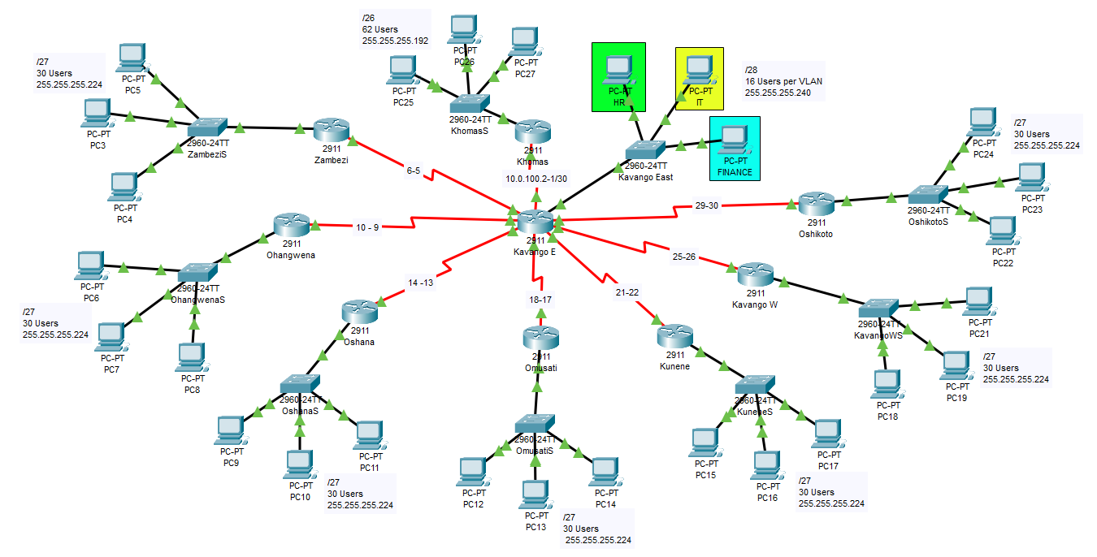
Fig 1: Screenshot of the network topology.
3. Network Topology Overview
The network topology consists of nine routers, one per branch and one HQ router. Each branch router is connected to HQ using serial connections to simulate WAN links. Each router connects to a switch, which connects to three PCs representing branch staff. The HQ router has a more complex internal network, divided into three VLANs representing HR, IT, and Finance departments.
VLANs at HQ:
- VLAN 11: HR
- VLAN 12: IT
- VLAN 13: Finance
Branches use a single subnet per branch and do not implement VLANs, keeping HQ as the central hub for department segregation.
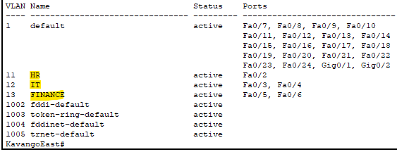
Fig 2: Screenshot of HQ VLAN configuration.

4. IP Addressing and Subnetting
The IP addressing scheme was carefully designed to separate networks for HQ and each branch. Private IP addresses were used according to RFC 1918.
HQ VLANs (/25)
- VLAN 11 (HR): 10.0.11.0/28 - Gateway: 10.0.11.1
- VLAN 12 (IT): 10.0.12.0/28 - Gateway: 10.0.12.1
- VLAN 13 (Finance): 10.0.13.0/28 - Gateway: 10.0.13.1
Each VLAN had a /28 subnet, providing 16 usable hosts per VLAN, enough for HR, IT, and Finance teams.
Branch Subnets
Branch | Subnet Block | Subnet Mask | Usable Hosts | Gateway
Khomas | 10.0.20.0/26 | 255.255.255.192 | 62 | 10.0.20.1
Zambezi | 10.0.30.0/27 | 255.255.255.224 | 30 | 10.0.30.1
Ohangwena | 10.0.40.0/27 | 255.255.255.224 | 30 | 10.0.40.1
Oshana | 10.0.50.0/27 | 255.255.255.224 | 30 | 10.0.50.1
Omusati | 10.0.60.0/27 | 255.255.255.224 | 30 | 10.0.60.1
Kunene | 10.0.70.0/27 | 255.255.255.224 | 30 | 10.0.70.1
Kavango West | 10.0.80.0/27 | 255.255.255.224 | 30 | 10.0.80.1
Oshikoto | 10.0.90.0/27 | 255.255.255.224 | 30 | 10.0.90.1
Branch | Subnet Block | Subnet Mask | Usable Hosts | Gateway

Reserved IPs:
- .1 for the router gateway in every subnet
- Other reserved addresses for static devices or servers if required’
WAN Subnets
Branch | IP Address | Branch | IP Address | Subnet | Usable Hosts
Khomas | 10.0.100.2 | Kavango E | 10.0.100.1 | /30 | 2
Zambezi | 10.0.100.6 | Kavango E | 10.0.100.5 | /30 | 2
Ohangwena | 10.0.100.10 | Kavango E | 10.0.100.9 | /30 | 2
Oshana | 10.0.100.14 | Kavango E | 10.0.100.13 | /30 | 2
Omusati | 10.0.100.18 | Kavango E | 10.0.100.17 | /30 | 2
Kunene | 10.0.100.22 | Kavango E | 10.0.100.21 | /30 | 2
Kavango W | 10.0.100.26 | Kavango E | 10.0.100.25 | /30 | 2
Oshikoto | 10.0.100.30 | Kavango E | 10.0.100.29 | /30 | 2

5. VLAN Implementation at HQ
To logically separate departments, VLANs were created on the HQ switch:
vlan 11
name HR
vlan 12
name IT
vlan 13
name FINANCE
The router uses subinterfaces with dot1Q encapsulation for inter-VLAN routing. This allows PCs in different VLANs to communicate through the router.
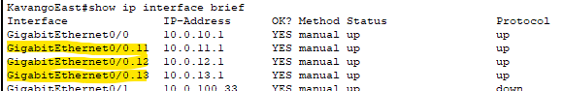
Fig 3: Screenshot of the subinterfaces.
6. OSPF Configuration
To enable dynamic routing between HQ and all branches, OSPF (Open Shortest Path First) was configured on all routers.
We used the process ID 10 and all routers were in the same area (Area 0)
Purpose:
- Ensures that all PCs in branches can communicate with HQ VLANs
- Automatically shares routes across the network
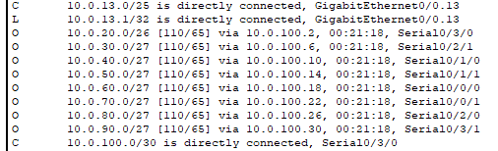
Fig 4: Screenshot of OSPF routing table.
7. DHCP Configuration
DHCP was implemented on all routers to automate IP assignment for PCs:
HQ VLAN pools (/28):
ip dhcp pool HR
network 10.0.11.0 255.255.255.240
default-router 10.0.11.1
dns-server 8.8.8.8
Branch pools (/26 or /27):
ip dhcp pool BRANCH-KHOMAS
network 10.0.20.0 255.255.255.192
default-router 10.0.20.1
dns-server 8.8.8.8
Reserved addresses: The first address in each subnet (.1) was reserved for the router interface (default gateway).
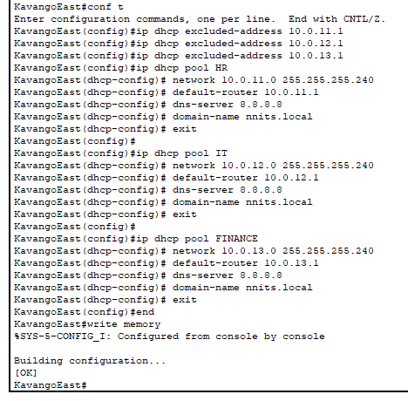
Fig 5: Screenshot of DHCP pool configurations on the HQ Router.
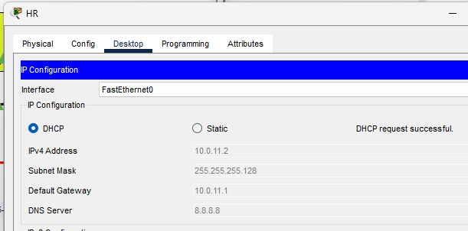
Fig 6: Screenshot showing devices successfully assigned IP addresses via DHCP.

8. Security Mechanisms
Several security features were implemented to demonstrate network hardening:
Enable secret passwords:
enable secret Mario@2025
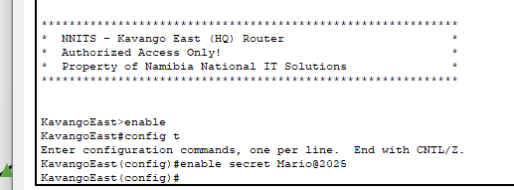
Fig 7: Screenshot showing the enable secret configuration.
- Encrypts privileged access passwords.
Service password encryption:
service password-encryption
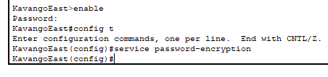
Fig 8: Screenshot showing the service password-encryption configuration.
- Encrypts all plain-text passwords in configurations.
Login block for brute-force prevention:
login block-for 60 attempts 3 within 30
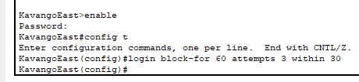
Fig 9: Screenshot showing the brute-force prevention configuration.
- Blocks login after 3 failed attempts within 30 seconds.

Banners for legal warning:
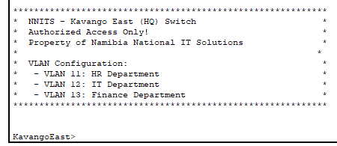
Fig 10: Screenshot of Kavango East banner.
9. Switch Port Configuration
- Trunk port for router connection:
interface gig 0/0
switchport mode trunk
switchport trunk allowed vlan 11,12,13
- Access ports for PCs in each VLAN:
interface range fa 1 - 2
switchport mode access
switchport access vlan 11
- Repeat for VLAN 12 (IT) and VLAN 13 (Finance)
10. Inter-VLAN Communication
- The HQ router handles routing between VLANs using sub interfaces.
- PCs in HR can ping PCs in IT or Finance via the router.
- Branch PCs can reach HQ VLANs via OSPF routing.
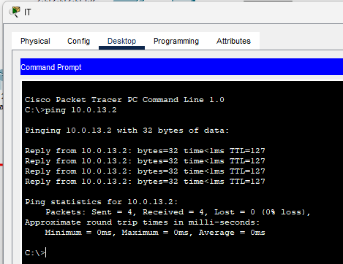
Fig 11: Screenshot of inter-VLAN ping test.
11. WAN Connectivity
- HQ router is connected to each branch via serial interfaces using /30 subnets.
- Ensures point-to-point communication and efficient use of IPs.
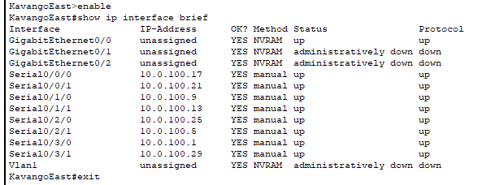
Fig 12: Screenshot of the WANs connected to the HQ router.
12. Project Summary and Achievements
This project demonstrates:
- IP Address Planning & Subnetting: Using /26, /27, 28 and /30 subnets with reserved gateway IPs
- VLAN Implementation: Logical separation of departments for security and efficiency
- Routing Protocols: OSPF ensures dynamic routing between HQ and all branches
- DHCP Management: Automated IP assignment for all devices
- Security Mechanisms: Password encryption, login block, banners, and access control
- Documentation Skills: Screenshots, detailed configurations, and explanations

Learning Outcomes:
- Applied real-world networking principles in a simulated enterprise.
- Implemented both LAN and WAN designs in Cisco Packet.

References (APA 7th Edition Style)
- Cisco Systems. (2023). Cisco Packet Tracer: Network simulation tool for teaching and learning networking. Cisco Networking Academy. https://www.netacad.com/courses/packet-tracer
- Cisco Systems. (2022). Introduction to Networks (Version 7.0): CCNA 1 Course Booklet. Cisco Press.
- Odom, W. (2020). CCNA 200-301 Official Cert Guide, Volume 1 (1st ed.). Cisco Press.
- Odom, W. (2020). CCNA 200-301 Official Cert Guide, Volume 2 (1st ed.). Cisco Press.
- Cisco Networking Academy. (2023). Routing and Switching Essentials v7.0 Course Materials. Cisco Networking Academy.
- Forouzan, B. A. (2017). Data Communications and Networking (5th ed.). McGraw-Hill Education.
- Tanenbaum, A. S., & Wetherall, D. J. (2011). Computer Networks (5th ed.). Pearson Education.
- Stallings, W. (2013). Foundations of Modern Networking: SDN, NFV, QoE, IoT, and Cloud. Addison-Wesley.
- Cisco Systems. (2021). Configure DHCP on Cisco Router. Cisco Documentation. https://www.cisco.com/c/en/us/support/docs/ip/dynamic-address-allocation-resolution/12468-4.html

